# Supplemental Figures

**Figure S1**

*Correlation Scatterplots for VSA Measures by Group*

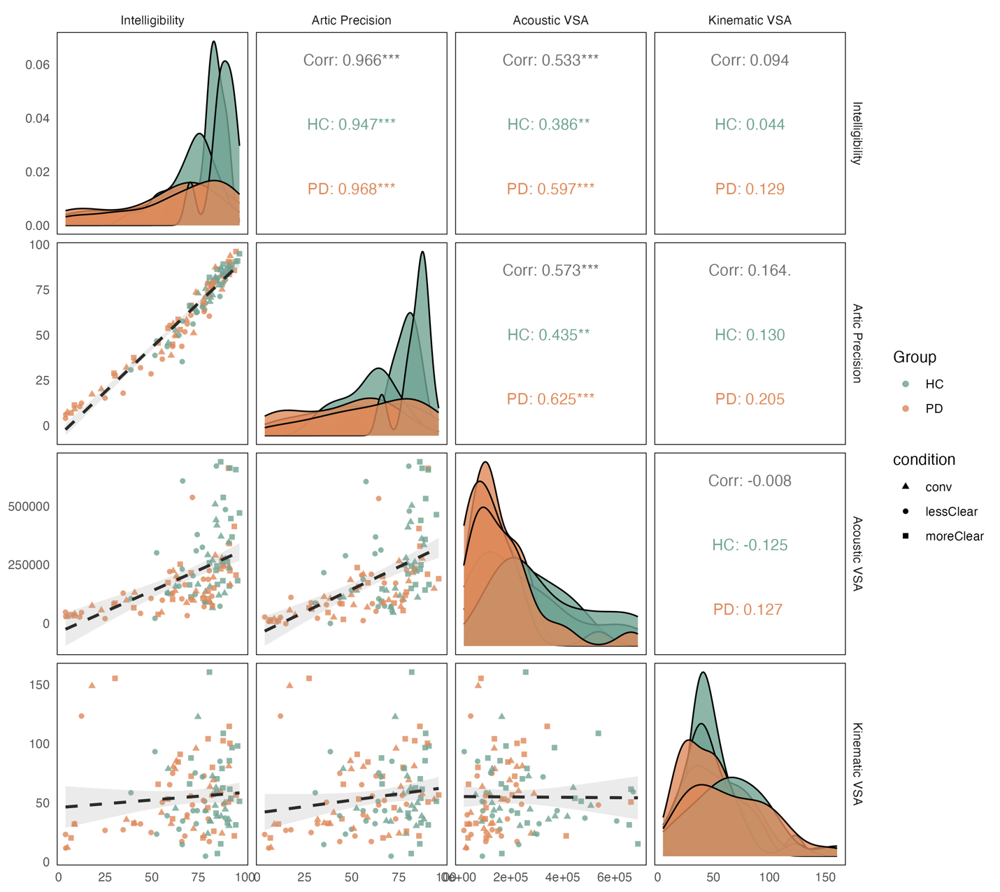

*Note.* Artic = articulatory, VSA = vowel space area, HC = healthy control, PD = Parkinson’s disease, conv = conversational, lessClear = less clear, moreClear = more clear

**Figure S2**

*Correlation Scatterplots for Diphthong Measures by Group*

*Note.* Artic = articulatory, F2 = second formant frequency, HC = healthy control, PD = Parkinson’s disease, conv = conversational, lessClear = less clear, moreClear = more clear

**Figure S3**

*Correlation Scatterplots for VSA Measures by Condition*

*Note.* Artic = articulatory, VSA = vowel space area, HC = healthy control, PD = Parkinson’s disease, conv = conversational, lessClear = less clear, moreClear = more clear

**Figure S4**

*Correlation Scatterplots for Diphthong Measures by Condition*

*Note.* Artic = articulatory, F2 = second formant frequency, HC = healthy control, PD = Parkinson’s disease, conv = conversational, lessClear = less clear, moreClear = more clear